ALW EARTHLINK
MARCH 2020

In this issue…..
Happy “Wearin’ o’ the Green” Day!
Camp H.O.P.E. 2020
Camp H.O.P.E. ‘Wish List’
Camper’s Corner
Meet the Author
Environmental News
And finally…..

Happy “Wearin’ o’ the Green” Day!
You don’t have to be Irish to celebrate St. Patrick’s Day, and since it is a GREEN holiday, maybe you can do something kind for the Earth before you drink your green beer or go looking for the lucky leprechaun! No matter what, have fun and be safe!

Camp H.O.P.E. 2020
We are set to meet our 2020 campers and their families in Kentucky on March 18! We are excited about giving them all the information for Camp H.O.P.E. We will give a report of the meeting in the April newsletter! Here are the students who were selected to be our 2020 campers – aren’t they a great looking bunch?
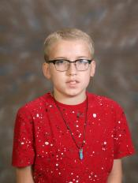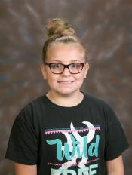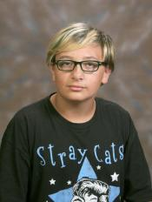

Camp H.O.P.E. ‘Wish List’
As always, we need a few items for camp that our budget doesn’t cover. If any of you feel generous and can donate some of these items, we’d appreciate it! You can shop for them yourselves, or you can send us the $$ and we’ll shop for you (and save you shipping fees!).
Needs:
12 bottles of hand sanitizer, one for each camper (definitely
needed after we handle critters, dig in the dirt, etc.!)
12 packages dental floss, one for each camper
12 tubes of toothpaste, one for each camper
12 packages of wipes, one for each camper
Bingo prizes – any small item the kids would have fun with

Thanks so much!

Camper’s Corner
This month we feature former camper John. This first photo is how he looked when we first met him…..
….and this is how he looks now!
John attends the University of Kentucky and is an outstanding student. He’s also part of an awesome rock band! We are so proud of him and all his accomplishments! Best wishes now and always, John!
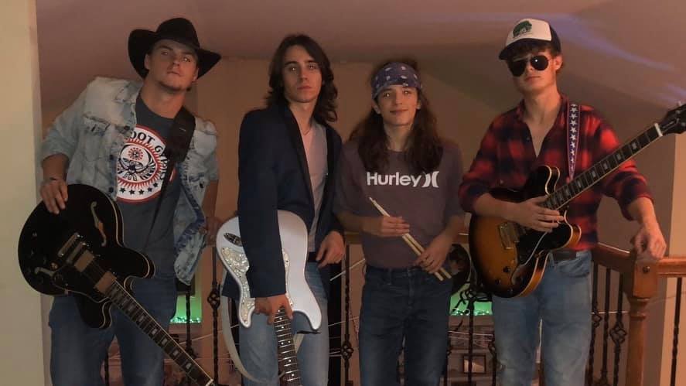

Meet the Author
Kevin Kurtz has loved books and nature since he was a kid growing up in upstate New York. He holds degrees in English literature and elementary education and started his career assisting with lab and field work at a marine biology research center.
Kevin then combined all of these experiences by working as an educator, program developer, and curriculum writer for organizations such as the Science Factory Children's Museum in Oregon and the South Carolina Aquarium in Charleston. Kevin's first children's book, A Day in the Salt Marsh, was published in 2007.
Kevin now lives in Rochester, New York. He continues to write books and visit schools around the country to introduce children to the wonders of reading, writing, science, and nature.

Each summer, Kevin has generously donated his book, A Day on the Mountain, to our Camp H.O.P.E. participants! Check out his website and his books at www.kevkurtz.com.

Environmental News
Why are Bats associated with Halloween?
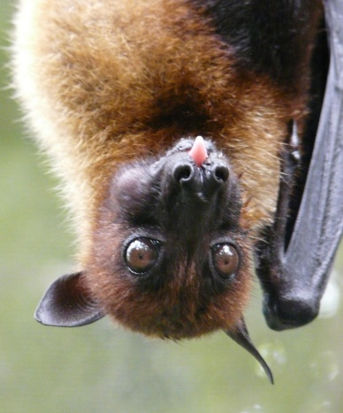
This Photo by Unknown Author is licensed under CC BY-SA
Did you ever wonder why bats are tied to Halloween? One theory is that early U.S. settlers from Europe came across large groups of bats during the fall. During this time, many species throughout the eastern U.S. display swarming behaviors as they mate and head to their winter roosts. These settlers might have linked these batty observations with traditional autumn holidays (such as Samhain, a precursor to our modern day Halloween). Another theory draws a link between bats and large bonfires held during this time of year. These warm fires may have attracted flying insects, which also brought in bats. And while stories of vampires could be found in old folklore across Europe, descriptions of blood-feeding bats in Central and South America by European explorers helped inspire spooky stories like Bram Stoker’s bat-like vampire, reinforcing a reputation as scary predators.
Bats are generally nocturnal, and people tend to react instinctively to creatures they see in the night. Being startled by a rat or an opossum often happens at night, and a friendly bat swooping nearby is understandably a little shocking. However, bats are extraordinary creatures that play a vital role in our world.
Here are some important bat facts that disprove any ‘scary’ notions.
- Bats are not ‘flying rats.’ In fact, they are more closely related to carnivores and ungulates than they are to rodents.
- Out of more than 1,400 species of bats, only three are of the vampire variety. Only one of those vampire bat species feeds on mammals, such as livestock. The other two species prefer the blood of birds.
- Bats aren’t interested in flying toward people or building a nest in someone’s hair. North American bats are all small, and like most wild animals, they prefer to avoid humans when possible.
- Bats play critical roles in ecosystems around the world. For example, they serve as important pollinators and seed dispersers in tropical and subtropical climates. They make tequila possible through agave pollination – that doesn’t sound scary!
Bats are amazing creatures that deserve protection and admiration. Bats are flying mammals! They protect our crops from millions of tons of flying pests every year. Let’s learn to appreciate and love the amazing bat!
(Bat Conservation International)

Whales on the Move
Did you know that every year the California gray whales migrate for about 20,000 kilometers (12,427 miles)? They migrate all the way from the Arctic Ocean to the Mexican coast and back. This is the longest migration undertaken by any mammal. In total, the California gray whale spends about 1/3 of its life migrating!

And finally…..

“Those who try to do something and fail
are infinitely better
than those who try to do nothing and succeed.”
Lloyd Jones

“Keep a green tree in your heart
and a singing bird may come.”
Chinese Proverb

“Do not go where the path may lead,
Go instead where there is no path
and leave a trail.”
Ralph Waldo Emerson

See you in April!

Love,

Wen

