**ALW EARTHLINK**

**DECEMBER 2020**

**In this issue…..**

**Happy Holidays!**

**Christmas Facts/Trivia**

**Christmas Giving Project**

**Camp H.O.P.E. 2021**

**Camper’s Corner**

**Environmental News**

**And finally…..**

**Happy Holidays!**

**C:\Program Files (x86)\Microsoft Office\MEDIA\CAGCAT10\j0183290.wmf C:\Program Files (x86)\Microsoft Office\MEDIA\CAGCAT10\j0285926.wmf**

**It’s been a very strange year because of Covid-19, and I know that many of us are toning down or cancelling our holiday gatherings/celebrations. But -- whatever you are celebrating and however you are able to connect with family and friends – may the spirit of the season fill you with much joy and with hope for the future! You will be in my thoughts as we enjoy this special time of year!**

**Christmas Facts/Trivia**



**Just for fun, here are some Christmas facts for you that may just win you that trivia contest when the family gets together! ☺**

1. **Where did “Jiminy Christmas” come from?**

**“Jimmy Christmas” or “Jiminy Christmas” is a direct reference to Jesus Christ and dates back to 1664, when it was first recorded as “Gemini,” a twist on the Latin phrase Jesu domini. The name of the Walt Disney character Jiminy Cricket was probably based on this phrase!**

1. **Why do we decorate trees?**

**Decorated trees were used in winter celebrations long before the advent of Christianity. Plants and trees that remained green all year had a special significance for people who lived in cold winter climates. Ancient people hung evergreen boughs over their doors and windows. Some believed that evergreens kept witches, ghosts, evil spirits, and illness away. Romans decorated evergreen trees with trinkets and topped them with an image of their sun god. Druid sorcerers hung golden apples and lit candles on oak trees to celebrate the winter solstice. Christian Christmas celebrations did indeed begin using the evergreen as a symbol about 400 years ago in Germany. This Christmas practice spread to most of northern Europe by the 19th century.**

1. **What is the origin of “Yuletide?”**

**The word Yuletide originated from the word Yule, which was recorded in Latin writings as early as A.D. 726. At that time, the form of the word was guili. Both terms refer to a 12-day pagan feast celebrated around the time of year that has come to be known as the Christmas season.**

1. **Why do we give gifts?**

**Ever wonder how the custom of giving Christmas gifts originated? (No, it’s not invented by the department stores!)**

**The ancient Romans gave each other gifts on the calends (first day) of January, and the practice spread throughout the Roman Europe. Eventually, Christians moved the custom to December 25, although many Christians still give gifts on January 6, the feast of the Epiphany, commemorating the manifestation of Jesus’ divine nature to the Magi. (Farmer’s Almanac)**

**Christmas Giving Project**

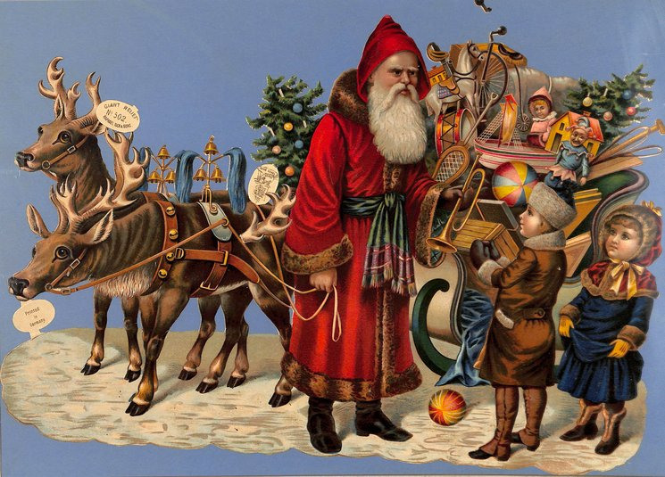

**Even in this difficult year, so many of you generously reached out to help us provide a special holiday celebration for a family in need, and we are most grateful!! We raised just over $900 to bring the family food, gift cards, toys, linens, towels, toiletries and more! We will be loading up the ‘sleigh’ and delivering the presents in person on December 9! Because of confidentiality, we cannot give you details about the family, nor can we take photos when we make our delivery. We will, however, have a follow-up report in January’s newsletter! Thanks to EVERYONE who contributed to this project!**

**Camp H.O.P.E. 2021**

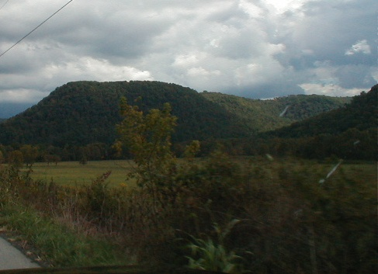

**A photo I took on the drive up to the camp!**

**We have been having ‘zoom’ chats with our campers and their family members. So far, we have connected with 10 of the 12 campers! They are all still VERY excited about coming to camp! We will be delivering a special Christmas gift bag to each camper on December 9. We asked the kids to send us an updated information sheet with their correct sizes, wishes, etc. (Yes, they have grown!) In January, we’ll be in touch with all you wonderful people who have ‘adopted’ a camper to give you the latest information on your specific child.**

**Thanks again to all of you for your continued interest/support/encouragement in this very worthwhile effort!**

**Camper’s Corner**

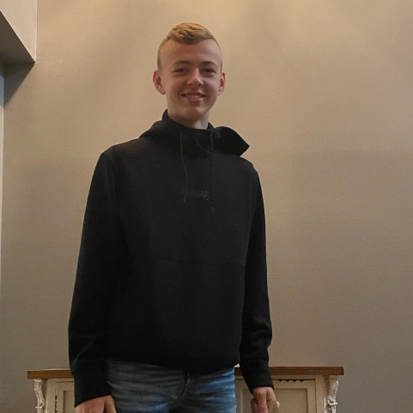

**Meet Bryce, another handsome young man who attended Camp H.O.P.E.! He was outgoing, adventurous, athletic, and lots of fun!**

**We especially remember the evening he let the girls use their make-up on him! ☺**

**Bryce was into sports at camp, and he has become an outstanding athlete for Estill County High School! We can’t wait to see what the future holds for him! We love you, Bryce!**

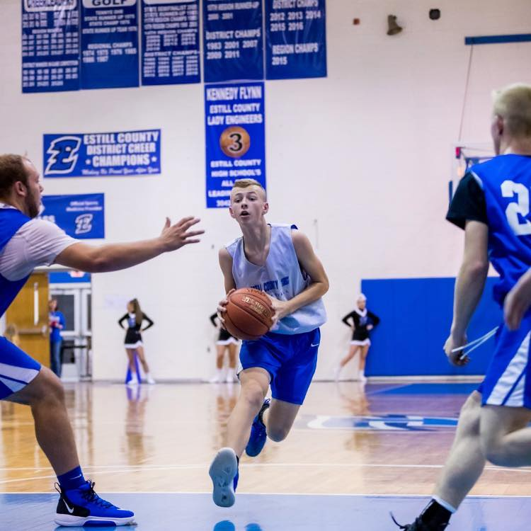

**A super basketball star!**

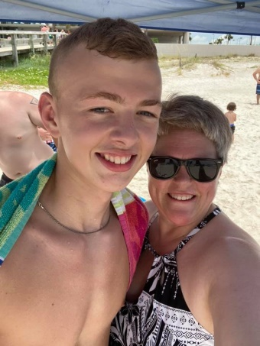 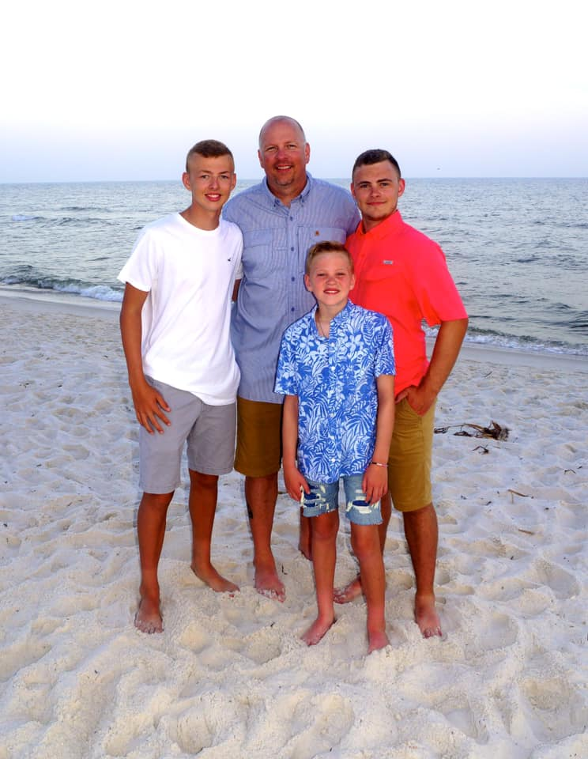

**With his Mom With Dad and brothers**

**Environmental News**

**8 Actions You Can Take To Protect Birds Where You Live**

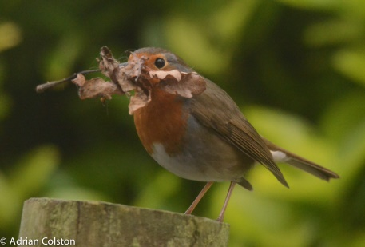

**Here are some tips on how you can help our feathered friends!**

1. **Reduce or eliminate pesticide and herbicide use. By using fewer chemicals in and around your home, you will help keep birds, pets and your family healthy.**
2. **Create or protect water sources in your yard. Birds need water to drink and bathe in, just like we do. Be sure to keep birdbaths clean and change the water three times per week when mosquitoes are breeding.**
3. **Identify the non-native invasive plants in your region, and work to remove them from your yard. Don’t bring any new invasives into your backyard habitat! Invasives don’t provide as much good food or habitat as natives do, and they can threaten healthy ecosystems.**
4. **Make your windows visible to birds to prevent collisions.**

**Put up screens, close drapes and blinds when you leave the house, or stick multiple decals on the glass – decals need to be no more than two to four inches apart to be effective.**

1. **Let your yard get a little messy. Leave snags for nesting places and stack downed tree limbs to create a brush pile, which is a great source of cover for birds during bad weather.**
2. **Close your blinds at night and turn off lights you aren’t using. Some birds use constellations to guide them on their annual migrations, and bright lights from windows and skylights can disrupt their steering senses.**
3. **Plant native plants. Native flora provides birds with food in the form of fruit and seeds, and is home to tasty invertebrates like bugs and spiders.**
4. **Attract hummingbirds with sugar water. Make it by combining four parts hot water to one part white sugar, boiled for one to two minutes. Never use honey, artificial sweeteners, or food coloring. Clean feeders with a solution of one part white vinegar to four parts water once a week.**

**(Audubon Society)**

**Eat better for the Planet (continued)**

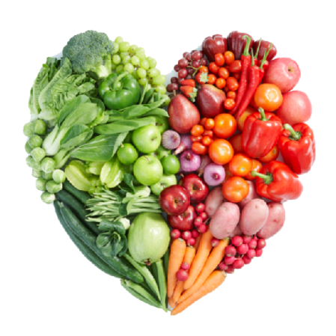

**Last month, we shared some ideas on how to be environmentally conscious – and still eat well! Here are some more eco-friendly food questions and answers.**

1. **What about chicken?**

**A number of studies have found that poultry has a lesser climate impact than other livestock. Modern-day chickens are bred to be extremely efficient at converting feed into meat, though this has prompted major concerns about animal welfare.**

1. **Should we just stop eating meat?**

**Not necessarily! A number of experts have argued that a sustainable food system can and should include plenty of animals. Cows and other livestock can be raised on pastures that would otherwise be unsuitable for growing crops, and they eat crop residues that would otherwise go to waste. They produce manure that we can use as fertilizer. And animal agriculture provides livelihoods for some 1.3 billion people worldwide.**

1. **How else can meat become more climate-friendly?**

**Advances in animal breeding, veterinary care, feed quality, and grazing systems are helping to shrink the climate footprint of livestock operations. The USA, for example, produces more beef today than it did in 1975, even though the total number of cattle has declined by about 1/3.**

1. **What about “fake meat?”**

**Plant-based meat substitutes made from vegetables, starches, oils, and synthesized proteins attempt to mimic the taste and texture of meat. While the jury is out on whether these products are healthier, they do likely have the smaller environmental footprint they promise: One study estimated that a Beyond Burger had just 1/10th the climate impact of a beef burger.**

1. **What kinds of seafood should I eat?**

**Wild fish often have a relatively small climate footprint, with the main source of emissions being the fuel burned by fishing boats. One recent analysis found that a number of popular wild fish – anchovies, sardines, herring, pollock, cod, haddock – have, on average, a lower carbon footprint than chicken or pork.**

**There is a huge caveat to all wild seafood, though: Most fisheries are being fished at their maximum sustainable level, while others are being overexploited. So there’s not a lot of room for everyone in the world to increase wild fish consumption.**

1. **How much impact do milk and cheese have on climate change?**

**Milk typically has a smaller climate footprint than chicken, eggs, or pork per pound. Yogurt, cottage cheese, and cream cheese are similar to milk.**

**But cheddar and other hard cheeses can have a significantly bigger footprint than chicken or pork, since it typically takes about 10 pounds of milk to make 1 pound of cheese. A vegan diet (no meat, dairy or eggs) has the smallest climate footprint.**

1. **If I can’t go vegan, what else can I try?**

**You could go vegetarian: no meat, poultry, or fish, but you can eat dairy and eggs. Food manufacturers and restaurants are used to accommodating vegetarians. Another option is to try cutting back to one serving of red meat per week, replacing the rest with chicken, pork, fish, or plant proteins.**

1. **Is organic produce better for the climate?**

**Organic produce is grown without synthetic fertilizers or pesticides, but that doesn’t mean it is necessarily better than conventionally grown produce from a climate perspective. In some cases it can be worse – organic farms often require more land.**

1. **Should I buy only produce that is local and seasonal?**

**In general, what you eat matters a lot more than where it comes from, since transportation accounts for only about 6% of food’s total climate footprint. That said, some perishable fruits and vegetables shipped by plane can have a hefty carbon footprint. By contrast, apples, oranges, and bananas are often shipped by sea, which is more fuel efficient. Cold-climate vegetables such as carrots, squash, and potatoes can be stored after the fall harvest and last through the winter.**

**Can I really make a difference?**

**It’s true that one person alone can make only a tiny dent in**

**the global climate problem. On the other hand, if many**

**people made changes to their diets, that could start to add**

**up. As the world’s population keeps growing, farmers and**

**ranchers will need to curb their emissions and grow more**

**food on less land to limit deforestation. Experts have argued**

**that it would make a big difference if the world’s heaviest**

**meat eaters scaled back – even moderately!**

**(Julia Moskin, Brad Plumer, Rebecca Lieberman and Eden Weingart)**

**And finally…..**

***Happiest of holidays to***

***you and yours!***

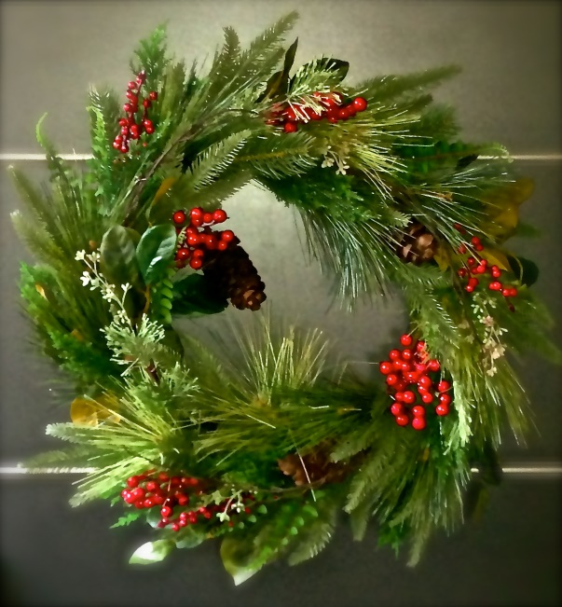

**See you in January – 2021!!!!!**

**Love,**

**Wen**